PRESSURE MEASUREMENT DEVICES
The pressure of a fluid is measured by the following devices:
1. Manometers 2. Mechanical Gauges.
Manometers
A manometer is an instrument that uses a column of liquid to measure pressure, although the term is currently often used to mean any pressure instrument. Manometers are defined as the devices used for measuring the pressure at a point in a fluid by balancing the column of fluid by the same or another column of the fluid. They are classified as:
(a) Simple Manometers, (b) Differential Manometers.
Simple Manometers
A simple manometer consists of a glass tube having one of its ends connected to a point where pressure is to be measured and other end remains open to atmosphere. Common types of simple manometers are:
1. Piezometer 2. U-tube Manometer 3. Single Column Manometer.
Piezometer
It is the simplest form of manometer used for measuring gauge pressures. One end of this manometer is connected to the point where pressure is to be measured and other end is open to the atmosphere as shown in Figure. The rise of liquid gives the pressure head at that point. If at a point A, the height of liquid say water is / in Piezometer tube, then pressure at A
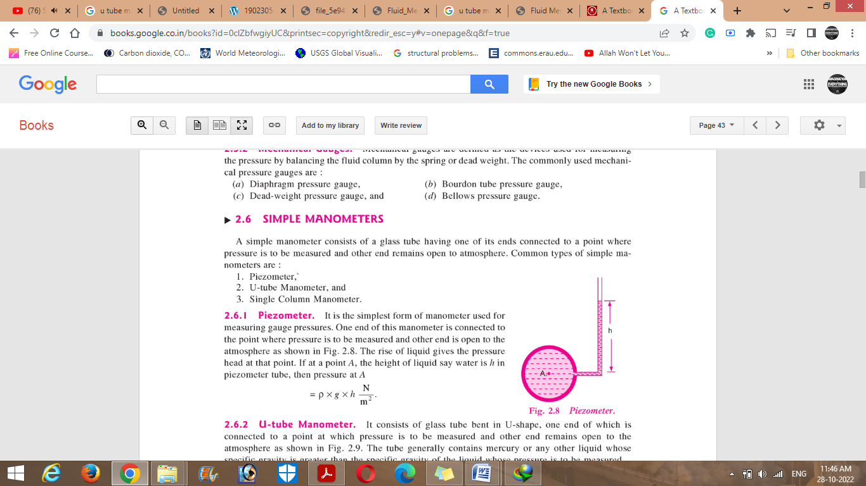


U-tube Manometer
It consists of glass tube bent in U-shape, one end of which is connected to a point at which pressure is to be measured and other end remains open to the atmosphere as shown in Figure.. The tube generally contains mercury or any other liquid whose specific gravity is greater than the specific gravity of the liquid whose pressure is to be measured.
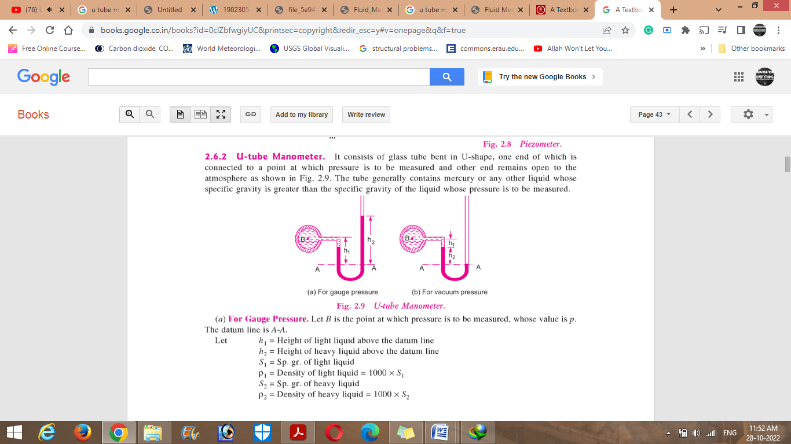
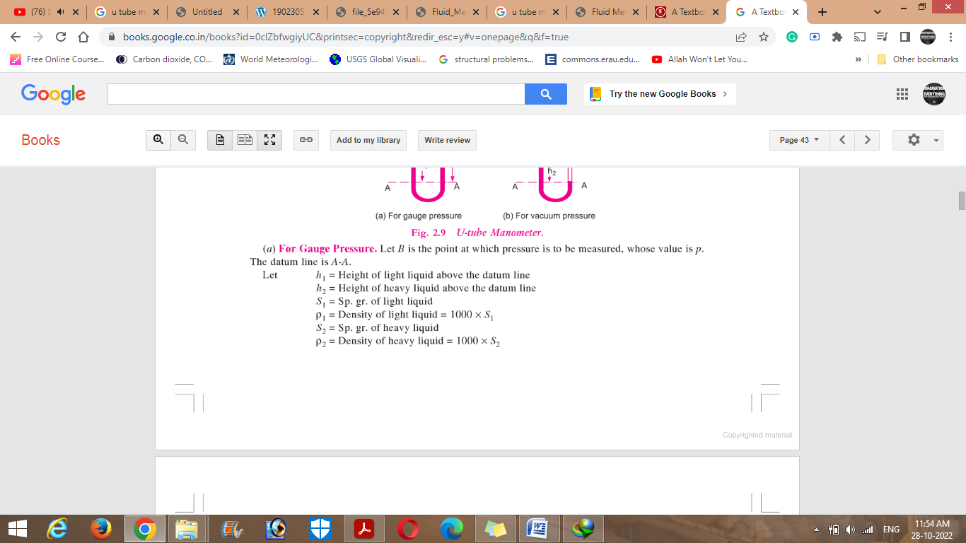
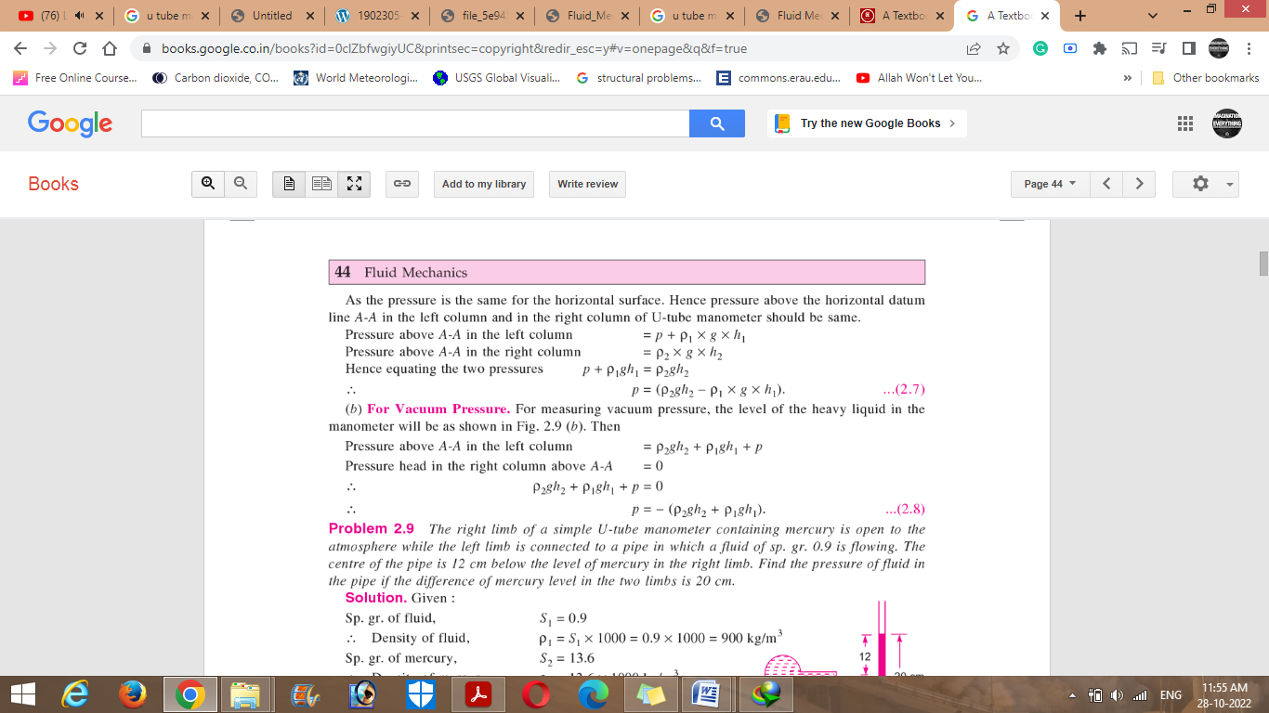

Differential Manometers
Differential manometers are the devices used for measuring the difference of pressures between two points in a pipe or in two different pipes. A differential manometer consists of a U-tube, contain ing a heavy liquid, whose two ends are connected to the points, whose difference of pressure is to be measured. Most commonly types of differential manometers are :
1. U-tube differential manometer 2. Inverted U-tube differential manometer.
U-tube differential manometer

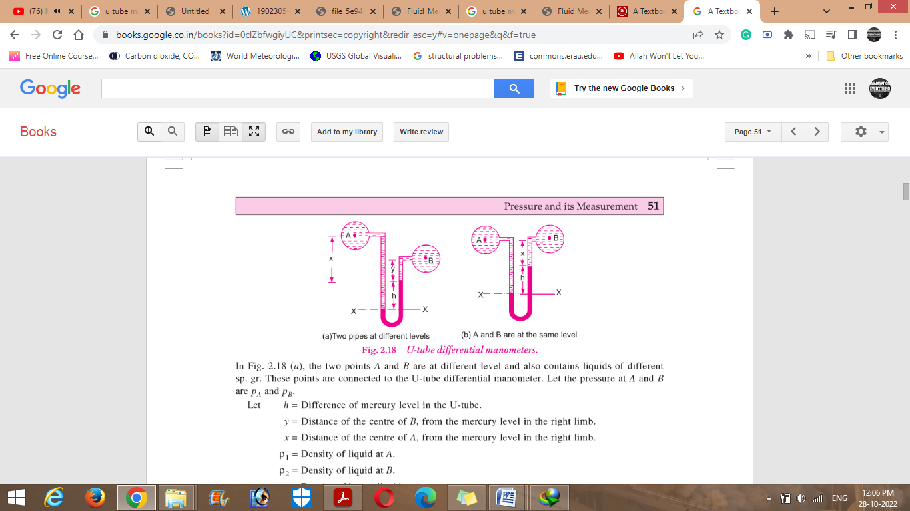
Figure shows the differential manometers of U-tube type. In Figure, the two points A and B are at different level and also contains liquids of different sp. gr. These points are connected to the U-tube differential manometer. Let the pressure at A and B are P_{A}, and P_{B} .
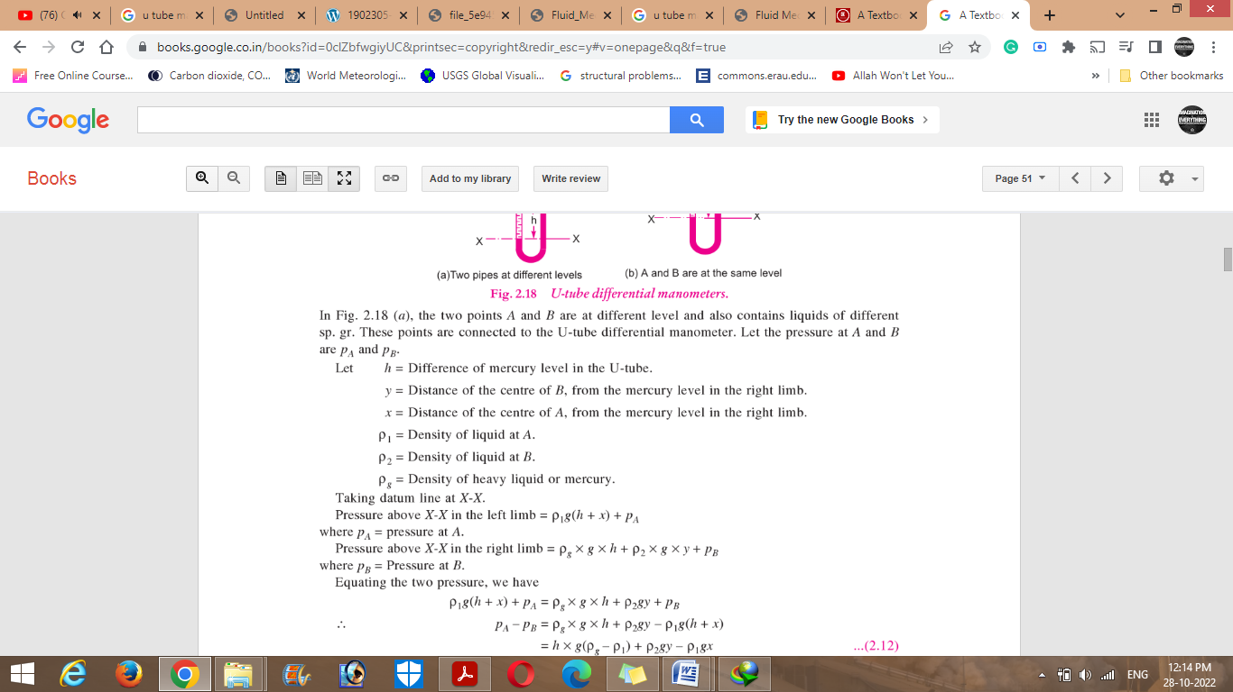
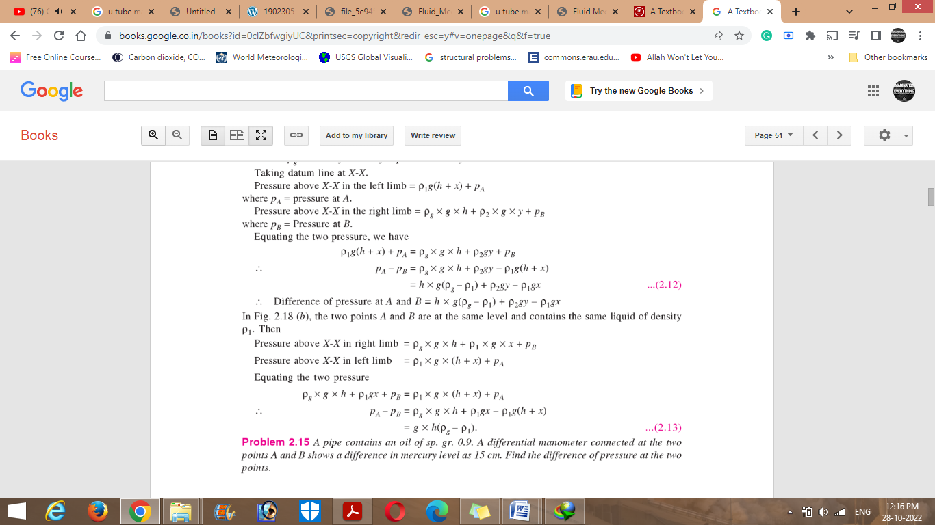



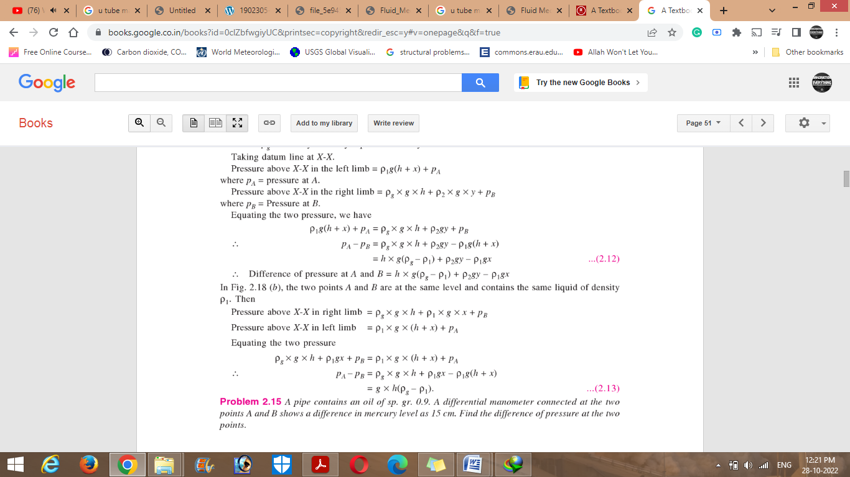
Inverted U-tube differential manometer
It consists of an inverted U-tube, containing a light liquid. The two ends of the tube are connected to the points whose difference of pressure is to be measured. It is used for measuring difference of low pressures. Figure shows an inverted U-tube differential manometer connected to the two points A and B. Let the pressure at A is more than the pressure at B.
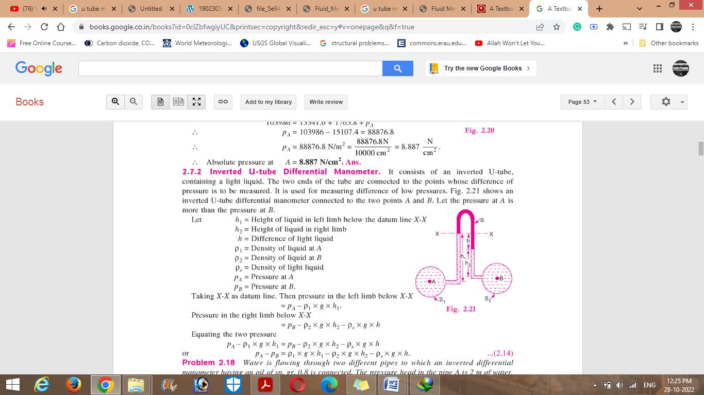

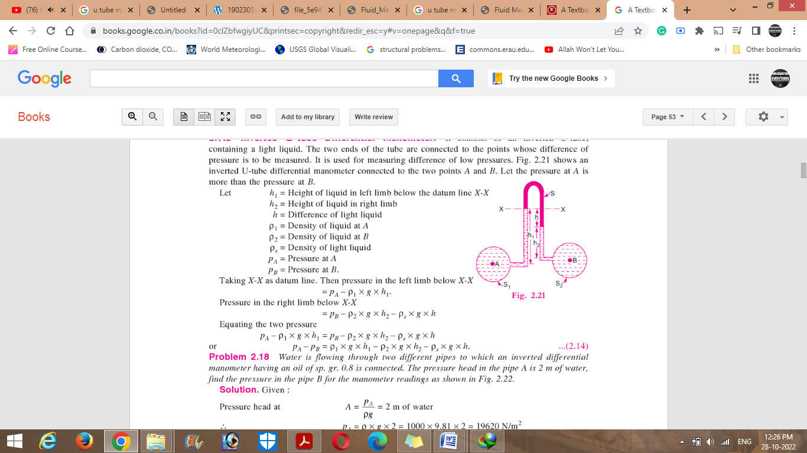

Bourdon Gage

The Bourdon Gauge is fitted with a transparent dial, which lets you see the internal workings of the gauge. The gauge consists of a thin walled closed ended tube which is oval in cross section. This tube is bent through an angle of about 270⁰ along its long axis. The open end of the tube is welded to a hollow mounting block which allows the pressurized fluid to reach the tube. This causes the pressure from the source to be transmitted directly to the inside of the bourdon tube. The applied pressure causes the oval tube to become rounder (since a round cross section has the maximum area for a given circumference). As it becomes rounder, the bourdon tube tends to uncurl which causes its free end to move. A system of linkages and levers transmits this motion to the gauge needle which moves over the scale. The Bourdon tube is usually an elliptical cross-section tube having a ‘C’ shape configuration. When pressure is admitted to the inside of the tube, an elastic deformation results, which tries to straighten up the tube. One end of the tube is fixed and the other end is free to move and is connected to a spring-loaded linkage, which amplifies the displacement and transforms it into an angular rotation of the pointer.

Bourdon Gauge

Pressure of a fluid is the normal force exerted by a fluid on a unit area. The pressure designated will be either an absolute pressure or a gauge pressure. Absolute pressure is measured relative to a perfect vacuum (absolute zero pressure), whereas gauge pressure is measured relative to the local atmospheric pressure. Absolute pressures are positive, but gauge pressure can be either positive (above atmospheric pressure) or negative (below atmospheric pressure) as shown in figure

Graphical Representation of Gage & Absolute Pressure
